Sample Format
- 5 x 30 minute sessions (2.5 hrs Croke Park + 30 minutes training at beginning of school year in staff meeting. 3 hours total)
- Teacher works with 2 / 3 students
- A week is allocated in school calendar for the sessions and teacher meets with students in his/her own time during that week.
- Teachers select the students they want to work with through a shared sheets document.
- Guidance counsellors, year head, deputy principal and principal work with students who are not selected by a teacher

Focus
- Pastoral focus
- Teacher is there to support student with the struggles they may be facing with study, stress, anxiety, deadlines etc
Sessions
Session | Time of Year | Focus
1 | Early October | Reflecting on 5th Year End of Year Results - study issues,  Worries, concerns, anxieties
2 | Mid November - after all students have received their CAO booklet and guidance counsellor has given a lesson to each class on CAO | Focus on applying for CAO, HEAR and DARE schemes. Alternatives to CAO - PLCs/Apprenticeships  Study techniques for Christmas exams
3 | January - after results have been sent home | Comparing 5th year end of year results and 6th year Christmas results. Looking ahead to the mocks
4 | March/April - after mock results are back | Comparing 6th year Christmas results to Mock results - looking ahead to LC.
5 | Mid May | Final check in - How is everything going studywise? Any subjects concerned about -projects etc,. Pastoral Support

Concerns | Resources
- If a teacher is concerned about a students level of stress or anxiety, they should submit a referral to the Care Team. | - Student Target Booklet – given to each student  - Stress Management and Anxiety Booklet shared with Teachers (students may already have this)  - This teacher Information Pack

Brief overview…
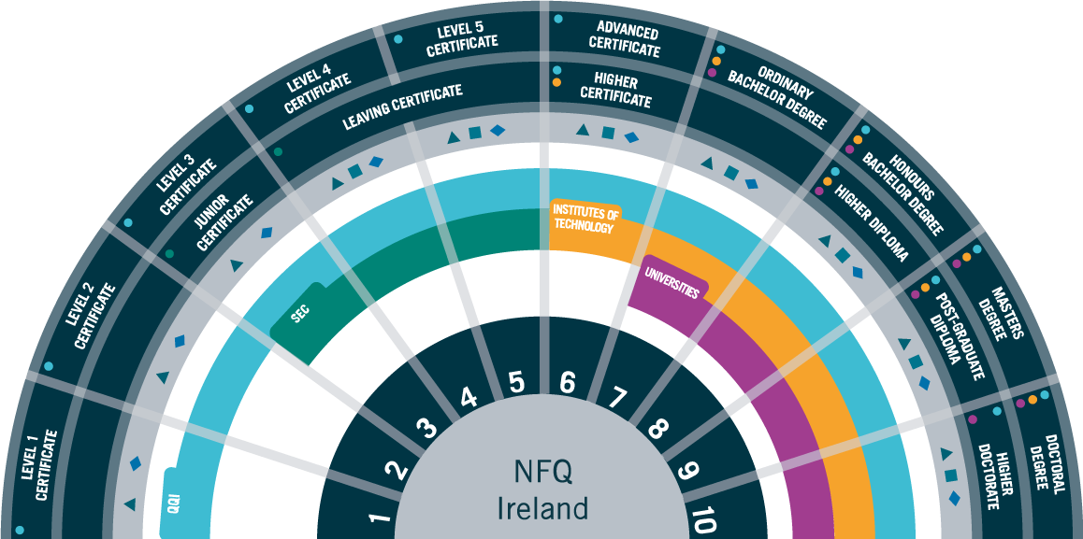
The QQI Levels
Level 5: | One year Post Leaving Certificate Course
Level 6: | Two year Post Leaving Certificate Course or Higher Certificate Course in an IT, TUD and Higher Education Institutions
Level 7: | Three year Ordinary Degree in an IT, TUD, Higher Education Institutions and some Universities
Level 8: | Three or Four year Honours Degree in an IT, TUD , Higher Education Institution or a University

How the CAO works:
- CAO opens for applications at 12:00 on the 5th November* most years.
- It is cheaper to apply prior to 17:15 on the 20th January
- Applications close on the 1st February though it is possible to make a late application for an additional cost
- Students can apply for up to TEN level 6/7 courses and TEN level 8 courses. They can add/remove courses and rearrange the order of courses for free up to 1st February.
- From 5th February to the 1st March, students can add/remove courses and rearrange the order of courses for a fee of €10.
- Changes cannot be made to the CAO from 1st March – 5th May.
- From 17:15 on the 5th May – 17:15 on the 1st July, students can change and rearrange courses as much as they like for free.
- Restricted courses normally require additional assessment procedures such as submitting a portfolio, attending an interview/audition etc,. Students must have applied to the CAO prior to the 1st February in order to apply for a restricted course. They also must add the course to their CAO prior to the 1st March.
- Applications to HEAR & DARE are made through cao.ie (see accesscollege.ie)
*Check dates to ensure they are correct for the current year
Timetable of Events / CAO Handbook
ORDER OF PREFERENCE IS OF UTMOST IMPORTANCE ON THE CAO FORM
Please speak to your guidance counsellor if you are unsure of any aspect of the CAO or refer to www.cao.ie
How Post Leaving Certificate Courses (PLCs) and Apprenticeships work…
PLC’s |  | Apprenticeships
- Most PLC colleges start accepting applications in January.  - Students apply directly to the College.  - They are then called for an interview and offered a place on the course based on their performance.  - They must achieve the required Leaving Cert grades – normally 5 H7/O6’s – to begin the course in September.  - See individual college websites for more info. |  | - Students must source their own apprenticeship work for traditional apprenticeships.  - Once they have been hired, their employed must register them with the training boards.  - Traditional Apprenticeships consist of 7 phases, four on the job and three off the job.  - The new apprenticeships are applied for through an organisation that coordinates the programmes.  - www.apprenticeship.ie
College and Course Entry Requirments
There are two types of entry requirements students must satisfy to gain entry onto third level courses:
- College Matriculation Entry Requirements
- Specific Course Requirements (minimum subject requirements)

College Matriculation Entry Requirements
The first requirements students must satisfy are the matriculation requirements for the third level institution they are interested in applying to. If a student does not meet these basic entry requirements he will not be accepted onto a course at that institution no matter how many points he has secured in his Leaving Certificate. The matriculation requirements vary across the third level institutions. It is important to check the website of the institution you are interested in applying to. Below is a summary for some of the local and popular higher level institutions.

NUI Institutions
UCD / UCC / NUIG / Maynooth University / Constituent Colleges / Royal College of Surgeons (RCSI) / NCAD / Shannon College of Hotel Management / Institute of Public Administration / St. Angela’s College, Sligo.
- Candidates must obtain a pass in at least six subjects.
- Of these six passes, students must achieve at least H5 in two higher level subjects and at least a grade O6/H7 in four subjects.
- For entry to all degrees: English, Irish and four other subjects in the Leaving Certificate are required.
- A third language must be included among the other subjects for Arts, Human Sciences, Law, Social Science, Commerce, Medicine and Health Sciences (the exception of Accounting, Business, Law and Finance in Maynooth University).
NUI Irish / Language Exemptions
Students with specific learning difficulties affecting their ability to learn a language (dyslexia) may apply for an exemption from the third language requirement at the NUI’s. Students born outside of Ireland may also apply for an exemption from the Irish matriculation requirement. However, these students may be legally obliged to attend and participate in Irish class. To apply for an exemption, you must complete and submit the Exemption Application Form. See www.nui.ie for more information.

Technological University of Dublin (City centre, Tallaght and Blanchardstown)
Level 8 (Honours Degree)
- A minimum of a grade H5 in two subjects at Higher Level and grade O6/H7 in four other subjects including Maths AND English OR Irish.
Level 6 and 7 (Higher Certificate and Ordinary Degree)
- Five grade O6/H7 or above including Maths AND English OR Irish.

LCVP is not accepted as a subject for matriculation purposes but is accepted as a subject which can be counted for points.
Trinity College Dublin
- Passes in six Leaving Certificate subjects, three of which must be at a grade H5 or above in higher level papers.
- These passes must include:
  - English AND
  - Mathematics and another language (Irish is sufficient) OR
  - Latin and another subject other than a language.
- Mathematics at foundation level is acceptable for minimum entry requirements for all courses except Nursing or Midwifery courses.
- Irish at foundation level is not acceptable for minimum entry requirements, course requirements or for scoring purposes.

TCD language exemptions
In the case of students who are exempt from Irish/modern languages, students need to apply to Trinity College directly for a waiver from the Irish/modern language requirement in the year they sit their Leaving Certificate. Applications are available from the Trinity website.

Dublin City University
- Pass six Leaving Certificate subjects, two of which must be H5 in a higher level exam.
- Passes must include English OR Irish AND Mathematics
Note: Bachelor of Education (Primary Teaching) requires a H5 in three subjects..

Course Specific Entry Requirements

As well as meeting the college Matriculation Requirements, students may be required to meet specific course requirements for some courses. This is usually higher level Maths, a lab science or other course specific subjects. A minimum grade in that subject is usually set in order for the applicant to gain admission to that course regardless of points. Below are some examples of a specific course requirement:
- Primary School Teaching – Higher level Irish at grade H5 or above
- Human Nutrition and Dietetics in Trinity College Dublin – H4 or above in higher level Chemistry
- Electronic Engineering, level 8, Institute of Technology, Tallaght – O4 or above in ordinary level Maths
There are two ways to check the specific entry requirements for CAO courses.
- Go course page on the college website and read the course information which will specify the subjects and minimum grade requirements.
- Go to www.qualifax.ie
  - Click on the ‘Students’ tab
  - In the left hand column select ‘Useful Tools’
  - Click on ‘Minimum Entry Requirements’. This allows you to search for courses that require a specific subject.

Post Leaving Certificate Courses (PLC’s)
What are PLC’s?
Post Leaving Certificate courses are full time 1 and 2 year courses which take place in Colleges of Further Education. There are a wide variety of subjects you can choose to study from animal care to music production to motor maintenance to photography.
Who studies a PLC?
Many students opt for a PLC when they are unsure of what they would like to study in college. Others do not want to commit to 3 or 4 years of study but would like to improve their chances of gaining employment. Some students will not have been offered the CAO course they wanted and will use a PLC as an alternative entry route. Many students who want to study a Creative Arts programme at third level will do a PLC portfolio course for a year before applying to college.
Where are the colleges?
There are many PLC colleges nearby: Crumlin College, Pearse College, Ballyfermot College, Kylemore College, St. Kevins, Rathmines College and many more. They all offer a unique set of course.
How do I apply?
Applications for PLC’s are made directly to the College offering the course. Students will then be invited for interview.
What are the entry requirements?
In order to be eligible for a PLC course, students must pass five subjects at Leaving Certificate. Some courses will require a specific subject or level. Always check the college website for up to date information!

Apprenticeships
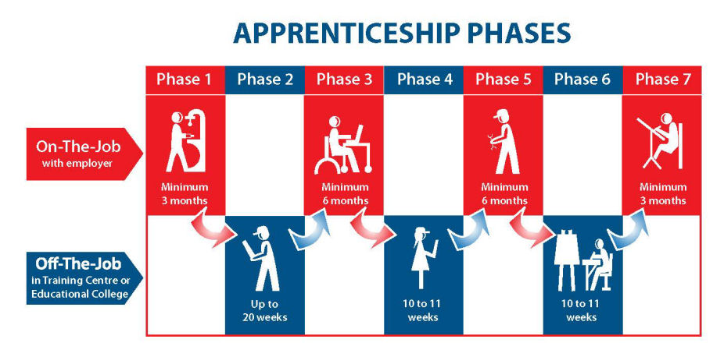
As the economy is improving, the number of available apprenticeship positions are growing. An apprenticeship takes 4 years to complete and is worth a level 6 qualification on the National Framework. Apprenticeships are spent between learning on-the-job and learning off-the-job in an education facility.
Traditional apprenticeships do not require specific subjects. However, it is important to note that Maths makes up a considerable part of the off-the-job training. Certain subjects are also deemed to be beneficial to a student who is hoping to enter a trade such as Technology or Design & Communication Graphics. More information on apprenticeships can be found at www.apprenticeship.ie.

