**Mentor Pack – Session 2**

Your main goal as a mentor for this session is to model a process for self-reflection on skills and interests for your mentees. This is an essential step in beginning to think critically about their future career and educational options and will help your mentees make a more informed choice.

**College Presentations (20 mins)**

Have your mentees present to the group on their chosen college. When each presentation is finished encourage the group to ask questions. If none are forthcoming, ask some prompting questions of your own. Some examples are given below.

* Why did they pick that college?
* If they included additional information beyond the questions given, why did they think it was interesting?
* If they did not include answers to all of the questions given, why? Was it hard to find?
* Where did they get most of their information? How did they find it?
* If they used any images, videos etc., why did they choose them?

When all the presentations and questions are finished, make sure to encourage students on their progress.

**Activity: Interview your Mentor (5-10 mins)**

Have your mentees fill in their worksheets on their mentor’s “strengths” and “passions”. Identify for them what your strengths are: what skills you possess, what you think you are good at/find easy, what personality traits you have. Next, identify for them your passions. What do you find most interesting, what do you enjoy doing the most? What do you get excited about? An example is provided below.

The purpose of this exercise is give the students a picture of you that they can then use to pick a course you might be interested in. In the next session the students will identify their own strengths and passions. Try be as open and honest as you can to help model the process for the students.

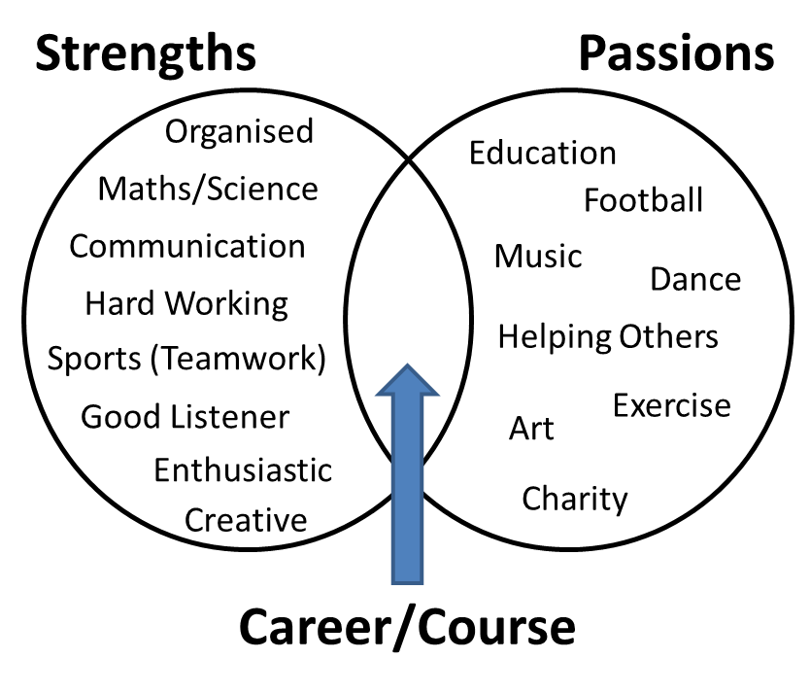

Once you have identified your strengths and Passions for the students ask them to think about careers that would best combine what you are good at and what you enjoy.

**Assignment: Pick a Course for your mentor (5 – 10 mins)**

Split your mentees into groups of two and ask them to identify a course they think you might like based on the Strengths/Passions Diagram they have created for you. The mentees must pick a course that is different to the one you have studied/currently are studying.

Explain to your mentees they must create a 5 minute presentation on their chosen college course for the next session. They are to pretend they are college admissions officers and must try to convince you their course is the best option for you. Their presentation should include

* What College is the course in?
* What were the LC points needed last year to be offered a place?
* What LC subjects/grades would your mentor need for the course?
* How many hours a week is the course
* Can you study abroad for a year or for a few months on this course?
* How many places were there on this course last year
* How many years is the course
* What kinds of careers do people go into after completing the course
* What strengths and passions of your mentor do you think suit this course?

**Note:** Encourage the students to include information not listed above that they find interesting.

**Mentee Pack – Session 2**

**Activity: Interview your Mentor**

Ask your mentor about their strengths and passions and fill in the diagram below. Leaving the centre blank.

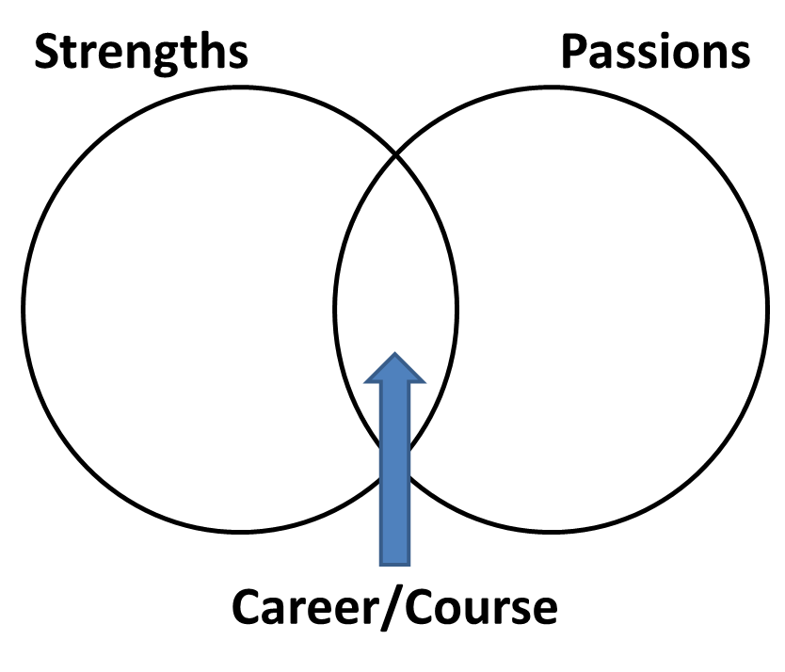

Can you think of any careers that would combine a lot of your mentor’s strengths and passions? Would they need any college courses for those careers?

**Group Assignment: Pick a College Course for your mentor**

Form a team with someone else from the group and pick a college course you think your mentor might like based on their strengths and passions diagram.

Before the next session your team must prepare a 5 minute presentation on your chosen course. Imagine you are an admissions officer in a college. It is your job to convince your mentor that your course would suit them best. You can give a simple oral presentation but it may be helpful and fun to use pictures, slides, music or videos too.

You can include any information on the course you like but your presentation must include answers to the following questions:

* What College is the course in?
* What were the LC points needed last year to be offered a place?
* How many hours a week is the course
* Can you study abroad for a year or for a few months on this course?
* How many places were there on this course last year
* How many years is the course
* What kinds of careers do people go into after completing the course
* What strengths and passions of your mentor do you think suit this course?

Don’t just stop with these questions, what else might your mentor want to know about the course?

Each group will have to present at the next session so make sure you practice once you have all your information.

**Research Tips:**

Carrersportal.ie has a lot of resources for second level students on possible career paths and college courses:

http://www.careersportal.ie/school/

Each college will have a book(s) containing lists and descriptions of the courses available as well as entry requirements. This book is called the prospectus and can be found online. Below are links to some college prospectus but many more are available both in Ireland and abroad:

Trinity College Dublin (TCD) Prospectus

<http://www.tcd.ie/study/assets/pdf/TCD-Prospectus-2015.pdf>

University College Dublin (UCD) Prospectus

<https://myucd.ucd.ie/undergraduate-prospectus/index.ezc>

Dublin City University Prospectus

<https://www.dcu.ie/prospective/degrees.php>

NUI Maynooth Prospectus

<https://www.maynoothuniversity.ie/study-maynooth/download-prospectus-booklets>

Dublin Institute of Technology Prospectus

<http://www.dit.ie/study/undergraduate/>

University College Cork (UCC) Prospectus

<http://www.ucc.ie/en/study/undergrad/what/download/>